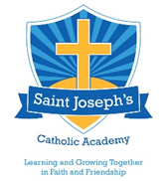
Summer Term
April 2026
St Joseph’s
Catholic Academy
Summer Term
April 2024
Summer Term
April 2024
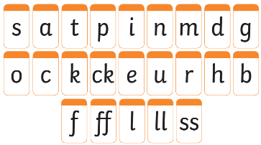
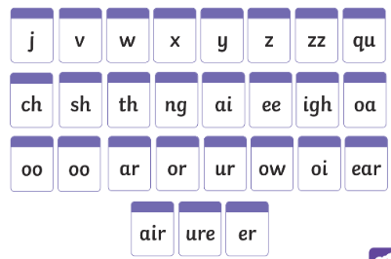


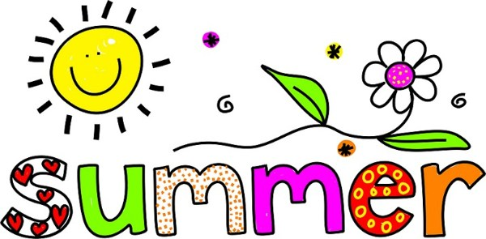
Reading
We will learning to read with confidence and fluency.
We will be reading using all the sounds we know in longer words.
Knowledge
- Jesus died on the cross and came back to life.
- Sequencing and re-telling stories.
- Observational drawing
- Basket weaving
- Name some famous seas and oceans
- Different types of fish and sharks
- What lives under the sea
- How to look after our oceans and seas.

Books we will learn through

The Easter Story
The Enormous Turnip
Little Red Riding Hood
Hansel and Gretel
The Little Red Hen

Rainbow Fish
Commotion in the Ocean
The singing Mermaid

Maths:
Number bonds to 5 and 10
Knowing all our numbers to 20.
Number patterns – odd and even
Patterns
Shape
Capacity
Sorting into groups
Writing
Writing simple sentences using the sounds we have learnt.
Using capital letters, finger spaces and full stops.

Our weekly themed areas will be as follows:

Traditional Tales

- The Easter Story
- Little Red Riding Hood
- The enormous Turnip
- Hansel and Gretel
- The Little Red Hen

Under the Sea

- Oceans
- Seas
- Fish
- Sharks
- Mermaids

I can’t believe we are in the final term of Reception! This newsletter will give you more information about what is going on in the classroom and what the children will be learning between April and July. We have learnt all phase 2 and 3 sounds, so please ensure you continue recapping with the sound purses. Reading in reception is VERY important, they need to read the same book at least 4 times as this will help your child develop fluency (being able to read without pausing). We will also be working hard to ensure the children are equipped and ready to move to year one.

Our topic for Summer One is ‘Traditional Tales’ and in Summer Two is ‘Under the Sea’, which will be taught through the Early Years Foundation Stage areas of learning: Religious Education, Communication and Language, Physical Development, Personal, Social and Emotional Development, Literacy, Mathematics, Understanding the World and Expressive Arts and Design.

Below are the important parts of our learning.

Reception Parents’ Newsletter

- Please label all items of clothes and shoes with your child’s name; including hats and scarfs.

- No jewellery to be worn on PE days, including earrings. Full PE kit to be kept in school at all times (PE kits will be sent home half termly to be washed).

- All children in Reception are entitled to Universal Free School Meals, please encourage your child to try hot dinners. Please refer to the menu on the school website.

- Fruit and milk are provided at dedicated snack time. Please bring £1 snack money into school each week to cover the cost of this.

Thank you

Please see me after school if you would like more information

Helping at home

• Listen to your child read their reading book. Your child should read at least 4 times a week. They should be able to read their book with ease.

• Sound purse. Practice sounds and tricky words at least 3 times a week.

• Share the library books that we send home with your child. Read it to them and discuss the text; what happened, what they can see, make predictions about the next page, etc.

• Encourage your child to practice writing their name, forming letters (lowercase and capital), shopping lists, etc.

• Practice counting a range of objects by ‘touch counting’ to at least 30.

Class teachers

Mrs Buckley

Miss Delves

Teaching Assistants

Mrs Bradley

Mrs Gilbert-Spencer

Miss Hogan

Monday
-Whole School Celebration of the Word

Tuesday
-Key Stage Celebration of the Word

Wednesday
-Homework books collected in
-P.E. (Miss Delves)

Thursday
-Music
-Mass

Friday
-Whole school celebration of our gifts
PE (Mrs Buckley)
-Homework books given out
-Library slot (Library books to be returned & swapped)

READING

Reading books and sound purses will be updated once a week. Please ensure they are in your child’s blue book bag every day.

Staff in Reception

Weekly Timetable

Mrs Buckley

Miss Delves

Mrs Bradley
Mrs Potts

Monday
-Gospel Assembly (whole school)
-P.E. (Mrs Buckley or Miss Delves)

Tuesday
-Key Stage Assembly

Wednesday
-Homework books collected in

Thursday
-Music
-Mass

Friday
-Success Assembly (whole school)
PE (Mrs Buckley or Mis Delves)
-Homework books given out
-Library slot (Library books to be returned & swapped)

READING

Reading books and sound purses will be updated once a week.
Monday
-Gospel Assembly (whole school)
-P.E. (Mrs Buckley or Miss Delves)

Tuesday
-Key Stage Assembly

Wednesday
-Homework books collected in

Thursday
-Music
-Mass

Friday
-Success Assembly (whole school)
PE (Mrs Buckley or Mis Delves)
-Homework books given out
-Library slot (Library books to be returned & swapped)

READING

Reading books and sound purses will be updated once a week.
Weekly Timetable

