Saint Joseph’s Catholic Academy
Part of the St. Gabriel the Archangel Multi Academy Trust
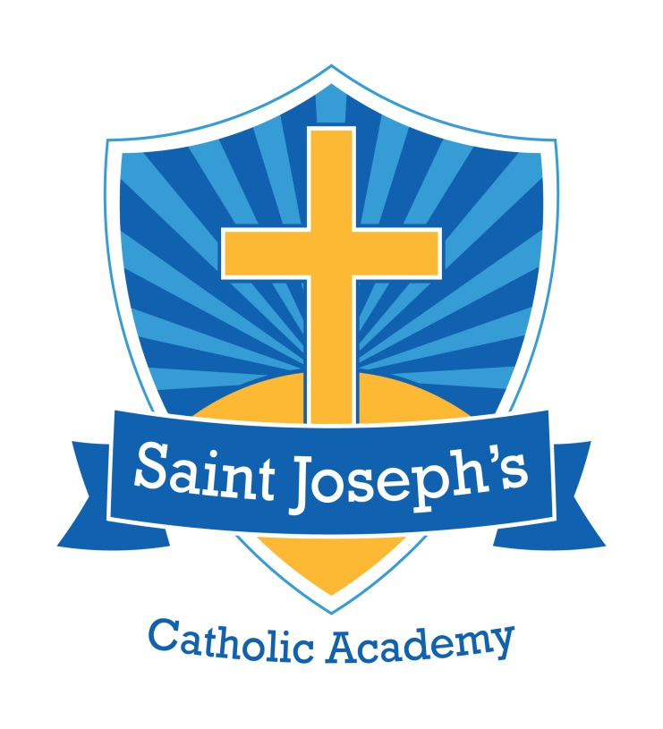

Inclusion Policy 2026/2027

St. Gabriel the Archangel Multi-Academy Trust Mission Statement:
Forming Christ-centred pilgrims of hope with kind hearts, questioning minds, a thirst for knowledge and a hunger for justice.
Saint Joseph’s Catholic Academy Mission Statement:
With God, all things are possible.
Special Needs Co-ordinator: Miss G. McGough
Academy Committee SEN Representative: Mrs Gillian Hussey
Our Vision for Inclusion
At St Joseph’s Catholic Academy, we believe that every child is a unique and precious gift from God, created in His image, loved unconditionally and deserving of every opportunity to flourish.
Rooted in our Catholic faith and inspired by our mission statement, “With God, all things are possible,” we are committed to building a school community where every child is welcomed, valued, understood and included. We recognise and celebrate the dignity, individuality, strengths and potential of every member of our school family.
Our vision is to nurture Christ-centred pilgrims of hope with kind hearts, questioning minds, a thirst for knowledge and a hunger for justice. We believe that inclusion is not simply about removing barriers to learning, but about creating a culture of belonging in which every child is empowered to participate, achieve, contribute and thrive.
Our commitment to inclusion is brought to life through our four curriculum aims:
- Aspiration: We hold high expectations for every child, recognising their unique gifts and talents and inspiring them to believe in their own potential. We refuse to allow disadvantage, disability or additional needs to place limits on what children can aspire to become.
- Resilience: We provide the understanding, encouragement, adaptations and support that enable children to overcome challenges, develop confidence and experience success. We recognise that resilience grows when children feel safe, supported and valued.
- Compassion: We nurture a community built on love, kindness, dignity and respect, where differences are celebrated, everyone has a voice and children learn to recognise and respond to the needs of others.
- Opportunity: We are determined to remove barriers and widen horizons, ensuring that every child can access a rich, ambitious curriculum and the wider experiences that help them discover their talents, develop their interests and imagine new possibilities for their future.
We recognise that equality does not always mean treating everyone in the same way. True inclusion means understanding each child's needs and providing the opportunities, adaptations and support that enable them to succeed.
We are especially committed to closing the gap in the lived experiences of our children, ensuring that disadvantage or additional need never determines a child's sense of belonging, access to opportunity or future aspirations.
Guided by Christ's example, we strive to be a community where no child is overlooked, no voice goes unheard and no barriers are accepted without challenge.
At St Joseph’s, inclusion is everyone's responsibility, belonging is everyone's right, and flourishing is our ambition for every child.
With God, all things are possible.
Saint Joseph’s Catholic Academy is a mainstream school which aims to include all pupils in all aspects of school life by:
- Removing the barriers to learning and participation that can hinder or exclude individual pupils or groups of pupils.
- Providing a caring and nurturing environment in which our pupils feel safe and secure so that can they develop their many potentials and access the wider school community.
- Providing a range of teaching styles to accommodate the different learning styles of all children.
- Equipping pupils with the skills, knowledge and attitudes necessary to succeed as responsible and valued members of the community.
- Providing all of our pupils with opportunities to access the wider school community
- Ensuring that the curriculum provided for children with SEN enables them to grow in the acquisition of skills, attitudes and values, thus realising their spiritual, emotional and academic development (School Mission Statement).
- Providing all of our pupils with educational experiences which enable them to develop resilience and independence
- Involving pupils and parents in planning and in making any decisions which affect them and their family.

Our policies for raising standards are for all children meaning that we create an environment of inclusive schooling for children with SEN. Early identification of difficulties and appropriate intervention will give children with SEN the best possible start to their school lives (DfEE-Excellence for all children).
Definition of Special Educational Needs
Special educational needs and disability code of practice: 0-25 years (June 2014) states:
A child of compulsory school age or a young person has a learning difficulty or disability if he or she:
- Has a significantly greater difficulty in learning than the majority of others of the same age, or
- Has a disability which prevents or hinders him or her from making use of facilities of a kind generally provided for others of the same age in mainstream schools or mainstream post-16 institutions

At St. Joseph’s, we identify a child as having SEN if:
- They score below 80 on one of our age appropriate standardised assessments
- They struggle to access age related expectations despite quality first teaching and classroom support
- They are working with an outside agency to help meet their needs

We also identify children as having SEN if their behaviour is such that they cannot access the foundation stage/ National Curriculum, or mix socially with their peers.
Objectives:
- To identify and provide for pupils who have special educational needs and additional needs as early as possible
- To work within the guidance provide in the SEND Code of Practice, 2014
- To operate a “whole pupil, whole school” approach to the management and provision of support for special educational needs, monitoring the progress of all pupils
- To provide a Special Educational Needs Co-ordinator(SENCO) who will work with the SEND Policy
- To provide support and advice for all staff in school working with special educational needs pupils
- To work in partnership with parents around all areas of a child’s education, and involve parents in reviewing and shaping SEND provision.

Identification and Assessment:
Identification: Saint Joseph’s Catholic Academy is committed to quality first teaching for all pupils. Class teachers monitor all pupils in order to identify pupils that are not making expected progress as early as possible.
The code of practice defines the four broad areas of need as;
Communication and interaction
Including speech, language and communication needs (SLCN) and Autism Spectrum Condition (ASC/ASD).
Cognition and Learning
Moderate learning difficulties (MLD)
Severe learning difficulties (SLD),
Profound and multiple learning difficulties (PMLD),
Specific learning difficulties (SpLD).
Sensory and/or physical needs
Vision impairment (VI)
Hearing impairment (HI)
Multi-sensory impairment (MSI)
Physical disability (PD)
Social, emotional and mental health difficulties. (SEMH)
These four broad areas of need give an overview of the range of needs that should be planned for but we undertakes assessments in order to meet children individual needs.
Parental views in identification and Assessment of pupils.
As a school, we see that parental views are essential in identifying a pupil’s needs and putting plans in place to support them.
If a parent has any concerns about any aspect of their child’s education, the first port of call will be their child’s class teacher. We operate an open-door policy within school; class teachers are usually available at the end of the school day and will happily make appointments to see parents if they require a longer discussion. At this point, teachers complete Cause for Concern forms detailing the child’s strengths, the concerns which staff or parents have and what has been put in place already to support this child. The class teacher may then seek the involvement of the school SENCO.
If we determine that a child has SEN, a Pupil Passport will be written in collaboration with parents/carers with the support of the SENCO where required. These passports are reviewed each term with the parents and, where appropriate, the children themselves.
If a parent wished to speak directly to the school SENCO, they can be contacted directly either at the end of the school day or via the email or telephone through the school office. There are SENCO Coffee Mornings with parents once a term which provide the parents with an opportunity to discuss their child’s needs with the SENCO and other parents of children with SEN.
Assessment
At Saint Joseph’s Catholic Academy the following sources of assessment information are taken into account:
- Nursery and Reception baseline assessment
- Nuffield speech and language assessment
- Assessments undertaken using the Stoke Speaks Out Child Development Tool
- Six monthly standardised assessments including BPVS language assessment, the Vernon spelling assessment, digit working memory test and the Salford reading and comprehension assessment where appropriate.
- Pre and post intervention assessments
- Y1 Phonics Screen
- Y2/Y6 SATs
- Assessment of progression using teacher assessments/records and school tracking system
- Published data
- Termly data collection from mathematics and English tests
- Attendance data

A child identified as having English as an additional language is not classified under the SEN code of Practice as having a Learning Difficulty. However, some of our children may also have a literacy and/or cognitive difficulty that is not directly linked to English being an addition language to them and so there may be some overlap.
It will not be assumed that a child who is not making expected progress has special educational needs. The school will consider other contributing factors and will work with pupil and parents to address these areas.
A Graduated Approach to SEN Support
All pupils are entitled to access quality first teaching regardless of their need and ability. The teacher will set suitable challenges, respond to pupils diverse needs and overcome potential barriers for pupils. The class teacher maintains responsibility of ensuring all pupils make progress. Where a child has been identified with Special Educational Needs the SENCO will advise and support around effective provision and outcomes.
We make sure that all children in our school are able to access appropriate and challenging learning opportunities in and out of the classroom. Our priority is the provision of high quality class teaching which is adapted to meet the needs of all our learners. At Saint Joseph’s, our class-based approaches might include alternative forms of recording work, visual prompts, small group or individual teaching etc. Class teachers and support staff are supported through regular professional development opportunities to support them in differentiating learning opportunities for the learners in their class. We take on board any advice and recommendations form external agencies and implement these in the best way to support the children.
Our school uses a wide range of intervention programmes available to support children who require support which goes beyond high quality class-based approaches.
All pupils will access a broad and balanced curriculum. Adaptations and reasonable adjustments will be made and children’s interests will be taken into account so that all pupils engage and thrive.
For children with significant or complex needs, our school seeks the advice of specialists, for example Speech and Language Therapists, Educational Psychologist, Specialist Teams. In some cases these specialists might work in school with the child, or school staff might attend therapy sessions out of school with the pupil. Before we contact any outside agency for support we make sure we speak to parents and carers.
Where additional levels of support are required, a personalised support plan for the pupil is created. We call these pupil passports and these outline the provision available to each child. These are written in collaboration with the pupil, the class teacher and parents. These are kept in the classroom and are regularly annotated. We make sure that parents receive copies. In addition, parents are fully involved in the planning and implementation of support for their child and have the opportunity to discuss their child’s progress at regular parent-teacher meetings and in an annual written report. The pupil passports are reviewed each term and re written on an annual basis.
Parental Involvement in the implementation of support
We make sure that parents and carers are fully involved with decisions regarding the support for their children.
Class teachers will inform and involve parents where a child has been identified as requiring additional support. Intervention, support strategies and/or reasonable adjustments will be agreed with parents in order to achieve desirable outcomes.
Our school uses Assess, Plan, Do and Review cycle to monitor the impact of all its provision to ensure that all pupils are making expected progress. This ensures early identification where pupils are not making expected progress and provision can be adapted to meet needs.
Monitoring and Evaluation of SEND provision
Every child is entitled to Quality First Teaching. To ensure this Senior Leadership Team or SENCO will monitor through:-
- Learning walks
- Book scrutiny
- Pupil Progress Meetings
- Analysis of data
- Pupil Conversations and pupil voice
- Parent conversations
- Appraisals
- CPD

To ensure quality and personalised provision the SENCO will monitor through;
- Intervention records / provision maps
- Analysis of pre and post data
- Observation of interventions
- Reviews with class teachers and parents
- Pupil conversations / pupil voice
- Parent conversations
- CPD

The outcomes of monitoring and evaluation of SEND provision will be shared with the Academy Committee SEN Representative termly.
The progress of pupils with SEND will form part of the conversation at performance management meetings.
Accessibility
The school continues to review how accessible the environment, curriculum and communication are for pupils and the wider community. (See accessibility plan).
Inclusion beyond the Classroom
St. Joseph’s is a fully inclusive school. We actively seek to ensure that all pupils, regardless of need, are able to attend enrichment opportunities such as after school clubs, school trips etc. Therefore, we work creatively and flexibly to make relevant adaptations to enable pupils with SEND to attend. For example, this might mean offering support to pupils attending after school clubs, booking accessible accommodation for residential trips etc. We have a range of out of school clubs and activities which change from time to time, all of which are available to every pupil regardless of need. For those pupils whose very high levels of need mean that the standard out of school activities on offer are inappropriate we seek to liaise with families about suitable alternatives (for example a day trip in place of an overnight residential). We make sure that any place we visit as a school is suitable for all of our children and the staff make sure they pre visit the site and complete a risk assessment before we take the children.
Social and Emotional Development for pupils.
The school supports overall wellbeing through pastoral, medical and social support.
Pastoral Support
For additional information see our Behaviour policy and SEND information report.
Medical Support
If a child requires medical support, a care plan will be completed alongside parents if one has not already been provided by a consultant. If it is felt that it would be helpful to do so, the school will contact the School Nursing Hub to ask for support. We work closely with parents medical teams to update these plans as and when necessary.
For additional information see Supporting Children with Medical Conditions policy.
Social Support
For additional information see Safeguarding policy and schools SEND information report.
Bullying
The school recognises that children with SEN could be more vulnerable to become involved in incidents of bullying.
For additional information see Anti-bullying policy and our SEND information report.
Working Together with Pupils and Families
Children who are looked after by the local authority have the same rights as all children. It is recognised that they may have additional needs due to attachment issues, early neglect, separation and loss, trauma and many placement moves. These barriers to learning may affect their educational outcomes and their personal, social and emotional development. The school’s designated teacher and SENCO, Miss McGough, will work with the head teacher, Mrs Hamilton, to monitor the progress and provision for pupils with SEN who are looked after.
Our school recognises that the partnership with parents and carers is vital in supporting the needs of individual pupils. For all pupils there are regular parent consultations and an annual written report. For pupils with SEN meetings will be held three times a year to review the impact of their individual provisions and to review their next steps.

We value the input of pupils around decisions to be made about their provision. Where appropriate, pupils will contribute to termly review meetings about their provision.

Our school welcomes the involvement of parents. Initially parents may wish to speak to class teachers regarding their comments or concerns about their children. The class teacher can then liaise with the SENCO or other appropriate staff, where applicable. The SENCO Miss McGough can be contacted through the school office. Parents will be invited to termly reviews of their child’s pupil passport and to regular parent-teacher meetings. There are half-termly ‘coffee mornings’ for parents of children with SEN to have an opportunity to meet with each other and talk to the SENCO and representatives from any other outside agencies who have been invited to attend.

- Below is the link to the Academy’s Special Educational Needs and Disability Information Report on our website.

- The Local Authority’s Local Offer can be found at www.stoke.gov.uk/localoffer

Admission Arrangements

Please see the school Admissions policy.

Transition Arrangements

Transition is arrangements for supporting children and young people in starting school, moving between year groups, and transitioning to high school or alternative provision.

Transition arrangements include:
- Meetings with new teachers
- Move up mornings/ days
- Time in new classroom
- Transition meeting with parents and new class teachers

Please see schools SEN information report for further information.
For children with SEN specific arrangements may be put into place to support their additional needs.
Training and Resources
How are resources matched to SEN?
Through the assess-plan-do review cycle provision will be put into place to meet an individual’s needs in a graduated way. For a child whose additional needs cannot be met in school through the schools existing resources, a request will be made for an assessment for an Education Health Care Plan (EHC).
How are the training needs of staff identified and planned for?
In our school, training is specifically tailored to the needs we identify across the school and is undertaken to equip staff with the necessary knowledge and strategies to support our pupils. We make sure all staff receive regular updates from the SENCO and specialist teachers. We have regular relevant training to support interventions and the delivery of specific programs to support children. All staff work closely with parents and outside agencies to learn specific skills to support children with additional needs. In school, we keep a record of the training staff have received.
Specialist Involvement
Where parents and staff feel it would be beneficial the school can liaise with outside agencies. Outside agencies will not be consulted without the agreement of parents. Agencies the school currently works with include Education Psychology, Occupational Therapy, SEND services, School Nurse, Health Visitor services, Speech and Language Therapy, CAMHS and Counselling services.
Roles and Responsibilities
The key responsibilities of the SENCO may include:
  - overseeing the day-to-day operation of the school’s SEN policy
  - co-ordinating provision for children with SEN
  - liaising with the relevant Designated Teacher where a looked after pupil has SEN
  - advising on the graduated approach to providing SEN support
  - advising on the deployment of the school’s delegated budget and other resources to meet pupils’ needs effectively
  - liaising with parents of pupils with SEN
  - liaising with early years providers, other schools, educational psychologists, health and social care professionals, and independent or voluntary bodies
  - being a key point of contact with external agencies, especially the local authority and its support services
  - liaising with potential next providers of education to ensure a pupil and their parents are informed about options and a smooth transition is planned
  - working with the head teacher and school governors to ensure that the school meets its responsibilities under the Equality Act (2010) with regard to reasonable adjustments and access arrangements
  - ensuring that the school keeps the records of all pupils with SEN up to date
The SEN Governor is Mrs Gillian Hussey. The SENCO and SEN Governor communicate regularly regarding the overview of the schools arrangements for SEN and disability. The SEN Governor offers support and challenge around the quality and impact of SEN provision.
Complaints
As a school, we hope that parents can work with staff to resolve any concerns they have. However, should a parent wish to make a complaint, guidance can be found in our Complaints Policy.
Compliance
This policy complies with the statutory requirement laid out in the SEND Code of Practice 0 – 25 and has been written with reference to the following guidance and documents:
• Children and Families Act 2014
• Equality Act 2010


Policy Written: | Miss G McGough | Date: October 2026
Approved by: | Senior Leadership Team | Date:
Approved by: | Staff team | Date:
Approved by: | Academy Policy Working Party | Date
Approved by: | Academy Committee | Date:
To be reviewed: | Date: | October 2027
Chair of Academy committee: | Rebecca Jones | Date:

