Saint Joseph’s Catholic Academy
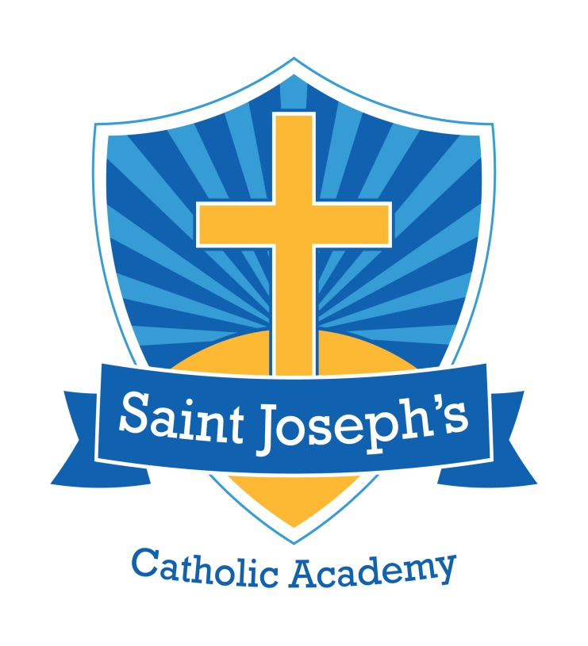
Part of the St. Gabriel the Archangel Multi Academy Trust


Special Educational Needs and Disability Information Report
2026/2027



How do staff at St Joseph’s know if children need extra help and what should I do if I think my child may have special educational needs?
Children with SEN are identified as early as possible within our setting. Our initial identification is usually through assessment or observation by school staff working directly with the child. We act quickly upon comments or concerns expressed by parents and carers. These concerns may be based on the pupil’s general wellbeing, their emotional or behavioural presentation, their progress in comparison to their peer group, or their profile against recognised characteristics of specific forms of SEND. We consider a child to have special educational needs if they score less than 80 on a standardised test, they struggle to access age related expectations even with quality first teaching and classroom support or if they are working with an outside agency to help meet their needs.

All of the staff at St Joseph’s receive regular and updated training to support them in the identification of SEND. The progress of all children is monitored by the class teachers and additional adults working in the classroom on a day to day basis. If class teachers identify a concern, they complete a Causing Concern form, which is handed to the SENCO. A meeting will then be held between the SENCO, class teacher and, if necessary at this stage, the child’s parents. A plan will be made surrounding the concern(s) identified. If the decision is made to place the child on the school SEN Register, the child’s parents will always be informed of this and invited to contribute to their child’s individual education plan (Pupil Passport).

As a school, we rigorously monitor children’s progress and attainment on a half termly basis. We do this through regular pupil progress meetings, book scrutiny, lesson observation and learning walks. The SENCO collects data about the progress of children with SEN on a half-termly basis to monitor the impact of interventions and, when necessary, the SENCO meets with class teachers and parents to analyse individual pupils’ progress and discuss any concerns. We make sure that the pupil, the pupil’s family and any additional adults supporting the pupil, are involved in on-going discussions relating to identification of and provision for the child’s needs. Depending upon the level of the child’s individual needs, we look at what level of support needs to be put into place. This could be implementing class-based support or supporting the staff in the classroom in running interventions. However, for some children, we may need to implement additional out of class support and interventions. For pupils with the highest levels of need, we will refer the pupils, with their parents’ permission, to out of school agencies for further advice and support. The SENCO keeps a register of all pupils requiring additional support in order to monitor the progress of these pupils and to plan for provision across the school.

If you have concerns about any aspect of your child’s education, the first port of call should be your child’s class teacher. We operate an open-door policy within school therefore class teachers are usually available at the end of the school day and are happy to make appointments if you require a longer discussion. The class teacher may then seek the involvement of the school SENCO.

Alternatively, the school SENCO can be contacted directly, either at the end of the school day, via the school email (stjoseph@sjnewman.co.uk) or via telephone through the school office. The SENCO at our school is Miss McGough.

How will St Joseph’s support my child?

We are a fully inclusive school. It is our aim that all children in our school are able to access appropriate and challenging learning opportunities in and out of the classroom. Our priority is the provision of high-quality class teaching which is differentiated to meet the needs of all our learners. In our school, class-based approaches might include alternative forms of recording work, visual prompts, small group or individual teaching. Class teachers and support staff are supported through regular professional development opportunities to support them in differentiating learning opportunities for the learners in their class.

Our school uses a wide range of intervention programmes available to support children who require support which goes beyond high quality class-based approaches. Some of these intervention approaches are published or commercially available packages of support which include, but are not limited to: Talking Partners, The Social Use of Language Programme, Stop Think Do Social Skills Intervention, Nessy Reading and Spelling, Toe by Toe and Plus One. We also employ bespoke and personalised approaches based on best practice guidance. All of our intervention packages are tailored to meet the pupil’s individual needs. All of our staff are trained in delivering the interventions that they use with children.

For children with significant or complex needs, the school seeks the advice of specialists, for example Speech and Language Therapists, Educational Psychologists and the Autism Team. In some cases, these specialists might work in school with the child, or school staff might attend therapy sessions out of school with the pupil. Before we contact any outside agency for support, we speak to parents and carers. We ensure that parents and carers are fully involved with decisions regarding the support for their children.

Where additional levels of support are required, a personalised support plan for the pupil is created. We call these pupil passports and these outline the provision available to each child. These are written in collaboration with the pupil, the class teacher and parents. These are kept in the classroom and are regularly annotated. We make sure that parents receive copies of these plans. In addition, parents are fully involved in the planning and implementation of support for their child and have the opportunity to discuss their child’s progress at termly passport review meetings, regular parent-teacher meetings and in an annual written report. The pupil passports are reviewed each term and re-drafted whenever pupils meet their targets. Our school SENCO - Miss McGough - is available to discuss any questions or concerns via email (stjosephs@sjnewman.co.uk) or in person to discuss pupil’s needs in more detail.

How will the curriculum be matched to my child's needs?

We know that all children are unique. All of our teachers take responsibility for meeting the needs of all learners in their class by differentiating the teaching and learning delivered within their lessons. Our teachers plan to meet children’s individual needs through detailed planning and differentiated activities. This is done in an exciting and interactive learning environment. Where pupils have SEND, class teachers will be aware of the pupil’s areas of strengths and weaknesses, and will make every effort to accommodate these.

Pupil Passports are used to inform all those working with your child and outline the strength and difficulties of the child. These also include details of support and strategies to use to support your child and enable them to access the curriculum and achieve. Along with adaptations to enable children with SEN to access the curriculum, the class teachers may provide the children with additional resources to support their learning and independent skills at home.

Where learners are working below age related expectations, class teachers adapt teaching to ensure that gaps in learners’ knowledge are covered and they can secure foundations to build upon. We aim to encourage independence in all learners and this is promoted by ensuring that independent work tasks are matched as far as possible to the strengths of the learners. For those learners who require a more specialist approach to learning, class teachers are encouraged to discuss approaches to adaptive teaching with the SENCO. All additional provision for pupils with SEND is overseen by the school SENCO, and monitoring of these pupils’ progress and their interventions takes place on a half-termly basis.

How will both you and I know how my child is doing and how will you help me to support my child's learning?

All of our school staff have high expectations for all learners. We make sure that monitoring of progress takes place on a day to day basis by class teachers, and they are often best placed to identify where progress is falling or excelling. On a day to day basis, the children know how they are doing though feedback from teachers, praise and rewards and next step marking.

For our learners with the most significant needs, daily contact with families takes place, for example through informal conversation at the end of the school day or sometimes in home-school books. We also make sure that a key person or your child’s class teacher can be spoken to at the beginning or end of the day. You are always welcome to make an appointment through the school office. Our school SENCO will happily meet with parents/carers by prior appointment. Our Parents Evenings are held twice a year giving time for sharing progress and discussing the appropriate next steps for your child.

The Pupil Passports are reviewed with parents, children, their class teacher and the SENCO on a termly basis. Any external agencies involved with your child are able to visit the school to observe or work with the child and they produce a report which outlines recommendations on how we can further support your child.

We have a rigorous tracking system in place to monitor children’s progress and attainment. With regard to children with SEN, their progress during interventions will take place on a six-weekly cycle and the SENCO will oversee the impact of interventions to ensure that each programme is well suited to the child’s needs. If a child is not making progress in an intervention, another programme will be used and monitored in the same way until we find a strategy which works best for the individual child.

For children with Education Health and Care Plans (EHCP) an annual review will be held. Parents are welcome to seek additional appointments to discuss their child’s progress as required, and class teachers are usually available for informal discussions at the end of each school day. Our school warmly welcomes and encourages parental involvement.

What support will there be for my child's/young person's overall wellbeing?

In our school, we know that children need supporting both in the classroom and outside. We make sure that all children’s needs are catered for and supported. We look at this in four main areas of support.

PASTORAL
We recognise that pupils with SEND can experience a range of social and emotional issues. As well as a whole school focus on social and emotional wellbeing through our PSHE and Religious Education teaching, we offer a range of interventions, both commercially published and bespoke, to address specific issues as they arise. We recognise that for some pupils, social and emotional factors can be complex, and therefore we seek to ensure that the provision we offer in this regard is highly personalised, and is generated through discussion with pupils and their families.

FRIENDSHIPS
All children in school are supported to develop relationships with their peers. For those pupils who find this most difficult there are alternative arrangements at play and lunchtime where play skills can be actively taught or modelled by staff. We work with all children to make sure we support and include each other. A range of support on the playground and a variety of activities are provided to make sure we encourage children to play together and build firm friendships. We have playground leaders within school in KS1 and KS2 who support on the playground every lunchtime.

PEER/SIBLING SUPPORT
It is sometimes appropriate for us to offer support to the peer groups/siblings of pupils with SEND. Sometimes this takes place in an open manner, enabling peers to ask questions and learn about the needs of their class mates (e.g. Circle Time discussions). At other times, this takes a more general form such as working with the class on celebrating diversity. We make sure that all children are included in our school.

BULLYING
The school holds a clear position on bullying, and all pupils are taught to distinguish bullying from isolated acts of unkindness. There are a range of assemblies and whole school events linked to anti bullying, and class teachers are vigilant in monitoring the children’s behaviour for indications of bullying. Where bullying is suspected, personalised support measures are put in place for both victims and perpetrators which take into account the needs of all the pupils involved.

In our school, the safety of all pupils is paramount. Therefore, information about pupils with SEND is communicated to relevant school staff. Where risks are identified, measures are taken to limit these.

What specialist services and expertise are available at or accessed by St Joseph’s?

SEND has a high priority in our school. We make sure that all school staff have a good awareness of SEND through regular staff meetings and training sessions. Regular meetings are held to enable staff to work with the SENCO to develop their practice in relation to the specific needs of the pupils in their classes. Many of our members of staff have experience of working with children with a range of needs, and expertise is regularly shared through staff training. As a school, we work closely with external agencies to gain advice relevant to individual children’s needs and individual staff attend training courses as appropriate. We also share and further develop best practice through partnership work with other schools in our collegiate.

Our SENCO and teachers work closely with our local SEND services, educational psychologists, speech and language teams, CAMHS, School Nurses and other external agencies to make sure we support all the children and meet their needs.

What training have the staff supporting children with SEND had?

In our school training is specifically tailored to needs and is undertaken to equip staff with the necessary knowledge as the need arises. We make sure all staff receive regular updates from the SENCO and specialist teachers. As a school, we have had training on behavior management, nurture of children, the new code of practice, emotion coaching, adaptive teaching strategies, managing social and emotional needs and specialist speech and language support using the Nuffield programme in EYFS. We have regular relevant training to support interventions and the delivery of specific programs to support children. All staff work closely with parents and outside agencies to learn specific skills to support children with additional needs. In school we hold a list of training opportunities which our staff members have had.

How will my child be included in activities outside of the classroom including school trips?

As an inclusive school setting, we seek to ensure that all pupils, regardless of need, are able to attend enrichment opportunities such as after school clubs and school trips. We work creatively and flexibly to make relevant adaptations to enable pupils with SEND to have these opportunities. For example, this might mean offering support to pupils attending after school clubs, booking accessible accommodation for residential trips etc. We have a range of out of school clubs and activities which change from time to time, all of which are available to every pupil regardless of need. For those pupils whose very high levels of need mean that the standard out of school activities on offer are inappropriate, we seek to liaise with families about suitable alternatives (for example a day trip in place of an overnight residential). We make sure that any place we visit as a school is suitable for all of our children and the staff make sure they pre visit the site and complete a risk assessment before we take the children.

How accessible is the school environment?

In school, we are consistently improving to make sure we are fully inclusive and accessible. Our school is fully wheelchair accessible. We have disabled car parking and a large accessible toilet. We make sure that all of our policies and practices are in line with the Equality Act 2010. We produce an accessibility plan that is available within school and this is re written on a three year rolling program. If needed, guidance from specialists would be sought if specialist equipment is required.

How will the school prepare and support my child to join the school or the next stage of education and life?

Entry into our school
Prior to entry to our school, it is usual for families of all pupils, including those with SEND, to visit for an informal tour of the school, usually with the head teacher. For those pupils with a high level of need, if it is agreed at this point that the school is able to meet the pupil’s needs, a multi-agency Action for Inclusion meeting may be held. This meeting is an opportunity for families and professionals to share information about the pupil and for actions to be set to ensure the pupil is appropriately included. Following this meeting, the school considers the provision necessary and, if appropriate, takes steps to acquire any resources needed to implement the provision. The action plan is then reviewed either prior to entry or shortly after. Prior to entry to school, a range of transition measures are in place. This is personalised to meet the needs of the pupil but may include visits to the setting, visits by school staff to the pupil’s home or current setting, a transition pack containing photos etc.

Transition into new settings
Wherever possible, we prepare pupils for transition to new settings in a manner most appropriate to the individual. For some pupils this takes the form of additional visits to the new setting. For others, this might be working through materials which address key aspects of the new setting. Some of our pupils benefit from lengthy transition work whereas others find an extended transition stressful, and require a shorter introduction. We work closely with families at this time to ensure consistency of information. We have good links with our local high schools and work closely with the staff from those settings.

How are the school’s resources allocated and matched to children's special educational needs?

In order to ensure that quality first teaching approaches are used fully in each classroom, a proportion of the budget is used towards class based provision. This might take the form of additional physical resources in classrooms e.g. additional computers, writing slopes, alternative seating etc. For those requiring provision additional to class based approaches, funding facilitates the school’s “menu” of intervention programmes. In some cases, it might also be used to provide additional human resource e.g. teaching assistants. Funding is matched to the provision required to enable pupils to achieve specified outcomes (i.e. outcome identified in discussion with teachers and parents or on EHC Plans). The budget is the responsibility of the head teacher and SENCO and regular discussion and monitoring takes place to ensure that resources are allocated appropriately and cost efficiently.

If your child has a birth- to-25 Education, Health and Care Plan our school will receive additional funding for their needs and they will have access to all facilities provided by the school. This funding is allocated to enable the child to achieve their full potential. This could be used in a variety of ways including one to one support, specialist equipment, and appropriate toys to aid development or the creation of pictorial support aids.

How is the decision made about what type and how much support my child will receive?

When children’s needs are initially identified, a discussion takes place between teachers, parents and pupils. At this meeting, desired outcomes for the pupil will be discussed and the provision or support the pupil needs to meet those outcomes will be agreed. School staff are usually best placed to advise on the nature of the support/provision needed, but occasionally the school seeks the support of other agencies to advise on this. We make sure that parents and pupils will be fully involved in decisions about support and provision, and any decisions to implement provision which is different from or additional to that received by the majority of children are made in conjunction with parents and pupils. On occasion, the school may seek the advice of external agencies to support the decision making process.

How are parents involved in St Joseph’s? How can I be involved?

Parents are encouraged to take an active role in the setting. They are invited in for termly reviews of their children’s passports and regular parent-teacher meetings. There is a coffee morning in school for parents of children with SEN every term. These are opportunities to speak to the SENCO, each other and any representatives from outside agencies who have been invited to attend. We operate an open door policy and encourage parents to come into school if they have any questions or queries. We are always happy to listen and support.

